1. Simulate the given network for 200 sec and plot the graph of the following:
a) TCP throughput Vs Simulation time (for every 50secs).
b) TCP packet delays Vs Simulation time (for every 50sec)
c) Packet loss Vs Simulation time (for every 50sec)
For each link, data rate and propagation delay are given.

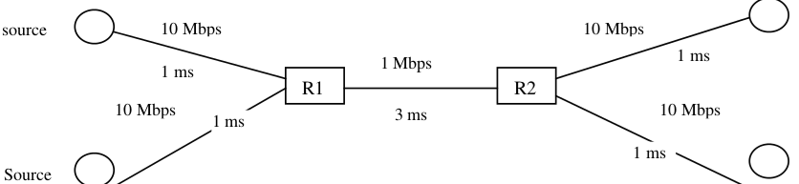

2. Simulate a mesh network with N nodes. The nodes are numbered sequentially started from 1. The odd numbered stations are sources and even numbered nodes re destinations. Assume that the all source nodes have UDP data from the starting of the simulation till the end of the simulation. Find the performance of the network in terms of throughput for the following cases:
a) Constant size UDP packets, varying N=2, 5, 10 and 15.
b) N=10, varying packet sizes of 256 bits, 512 bits, 2048 bits, and 8192 bits.

